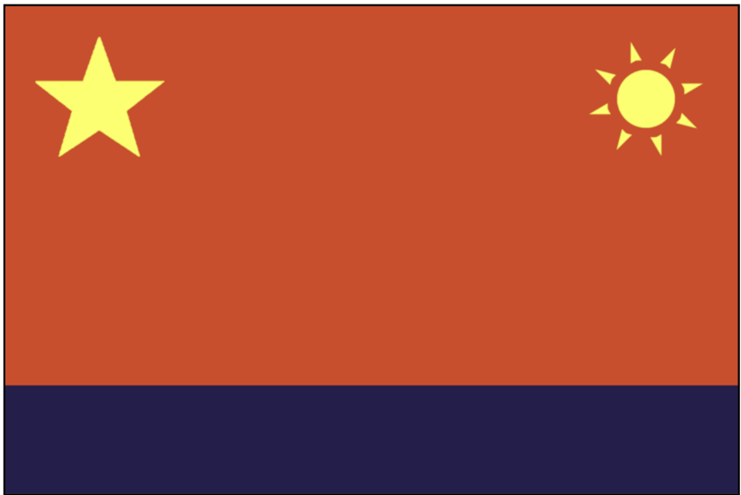


Population: 80 CPA citizens

Starting Crew, Resources and Units:
2 Untrained Crew
2 Security Units
1 Engineer Crew
1 Medic Crew
1 Scientist Crew
2 Fuel
2 Food
2 Water

The Fuerza León ("Lion Force" in a long-dead language) is a bulk hauler under the CPA flag, designed for deep space cargo transport. Its immense storage bays were previously packed full of all sorts of goods en route for Rosal when the Wolves attacked. The captain chose to jettison the contents of several of them in order to gain speed against your pursuers. There is still a lot of cargo onboard but it's all wildly disorganized due to multiple emergency jumps and the cargo manifest was scrambled beyond repair after a Wolf hacking attempt against the ship's mainframe. The empty bays could prove useful; your ship's engineer assures you that just about anything could be jury rigged into place without any demolition or reorganization. Despite its size, this class of vessel was designed to require minimal crew. Several specialists from the CPA were en route as passengers when the attack happened, and they have already proven invaluable to the fleet.

The FAS is an old enemy but you have more in common with them now than you do with the New Nations. You are concerned that the President of the Council was born a resident of the FAS – though legally the President is bound to neutrality, you should be observant and ensure it doesn't sway their decision-making.

The SAN are old friends, although in more recent times they've gradually been focusing more on themselves and your diplomatic ties have weakened.

Rosal are loud and boorish, but ultimately harmless, and can be useful allies if the FAS are getting their way too often.

Proxima are a challenge to negotiate and find consensus with but they bring important military and production support so must be tolerated as much as possible.

Gliese have an annoying habit of exhibiting a “New Nation” style rebellious spirit, but you try to stay on good terms with them given their control of important resources.

Helvetii is an enigma and a recent addition to the Council. They seem to have the “New Nation spark” but are very open minded and consistent with their neutral political approach. They could prove to be a good negotiator and ally.

The actions of the Wolves may have taken you by surprise but you always knew they would do something despicable. Even before 'The Attack' you knew they couldn't be trusted and their politicians were unredeemable. Every opportunity should be taken to show them that they haven't won and that they are not safe.

Objectives

• You have some very skilled specialists traveling with you (represented by powerful action cards). Talk with your council member, they may be able to use these as bargaining chips.

• Try to maintain a neutral stance with regards to the other nations, unless one appears to be sympathetic towards the Wolves. Help maintain a neutral balance of political power amongst the nations.

• Your Cargo Bays can provide some much needed resources to the fleet but are unpredictable with what can be found there. Consider replacing them with more efficient and predictable stations, and determine what would best fit the needs of the fleet. The science ships (Endeavour and Baltar) may be able to come up with some ideas.

